Personal Taxation and Behavior

Assuming that an individual’s consumption and saving reasons during given rear are the result of a planning process that consumer their lifetime economic circumstances

We will set the lifecycle model to explore the part of types on their savings.

* Consider a taxpayer who expects to live for two periods:

now (period 0) and future (period 1)

the taxpayer has income I dollars now, and knows their income will be I’ in the future.

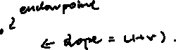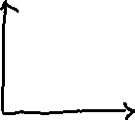

Inter___ Budget Constraint

The schedule interest all feasible consumption levels across time

Provide that the individual can borrow or lend at interest rate r, the budget constraint is a straight line whose slope has an absolute value of (1+r)

* Let I0 = 100, I1 = 80, r = 0.1 (indicating an interest rate of 10%)

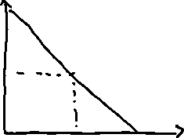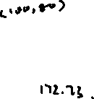

Maximum future saving = save all income totally *(1+r) = 100(1+r) = 110

Maximum future consumption = maximum future savings + future income = 110+80 = 190

Maximum future loan payment = maximum borrowed funds * (1+r)

I0 = max borrowed funds * (1+r) => max borrowed funds = 80/1.1 = 72.73

Max present consumption = I0+ max borrowed funds = 100+72.73 = 172.73

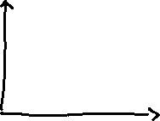

Assume that the indifference curve tangent the budget constrain line on (70, 113):

C0* = 70, C1* = 113

In our example, the consumer saves : Saving before tax = I0 – C0* = 100 – 70 = 30

If C0>I0 then it is borrowing, C0<I0 it is saving.

We will consider less where interest payments on consumption in future, include things are not

Let the tax rate on interest on income be t

In an example let t = 0.5, relating a 50% tax rate

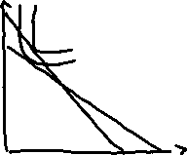

The interest rate budget constraint savings pluses through the endowment point

Future saving = (today’s saving)(1+(1-t)r) = 100 * (1+(1-0.5)*0.1) = 105

Max future consumption = future income + max future savings = 80+105 = 185

Max future tax payment = max borrowing today*(post tax interest)

I1 = max borrowing today(1+r)

80 = max borrowing today (1+0.05)

80/105 = max borrowing today

Max borrowing today = 76.19

Assuming interest payment are tax deductible

Max future consumption = max borrowing today + future income = 76.19 + 100 = 176.19

C0* = 70, C0t = 80, C1* = 113, C1t = 102

In this example, saving after tax is imposed = I0-C0t = 100 – 80 = 20

Saving before tax imposed = I0-C0* = 100-70 = 30

Savings decreased by tax = 30-20 = 10

Imposing a tax cant either increase or decrease saving